PROJECT REPORT
ON
ONLINE VOTING SYSTEM
A PROJECT REPORT SUBMITTED IN THE PARTIAL FULFILLMENT OF THE DEGREE
SCVB GOVT. COLLEGE
PALAMPUR

SUBMITTED TO: SUBMITTED BY:
MISS MEHAK MEHRA HARSH RANA
MISS DISHA VERMA 6TH SEMESTER
MISS SWATI SOOD Roll No-6190710023

GROUP DETAIL
STUDENTS NAME: ROLL NO.
HARSH RANA 6190710023
MALVI PARMAR 6190710026
RITIK KATOCH 6190710039
VIVEK JAGGI 6190710054
CLASS: BCA 6TH SEMESTER

PARTICIPATION IN THE PROJECT
All colleagues have played equivalent role in the project. The idea of creating the project in this topic is of Harsh then the accomplishment of the project is done by all the members. All the colleagues has created equal pages of the particular field. For Example:- Harsh and Ritik has created all the pages and tables of “Admin” field where you can see the result of voting and add candidate for voting. Vivek and Malvi has created all the pages and tables of “Election” field where you can register yourself as new voter and vote for your favorite candidate . And like this all the project has been completed.
CERTIFICATE

This is certified that the project report entitled “ONLINE VOTING SYSTEM” submitted by “Harsh Rana” a bonafide piece of work conducted under my guidance to the best of my knowledge and belief this is their original work and this wholly or partially, has not been submitted for any other degree of this or any other university.
It may considered for evaluation in partial fulfillment of the requirement for the award of Degree of Bachelor of Computer Application.
Place: Palampur
(SCVB Government College Palampur)

Signature of Teachers

ACKNOWLEDGEMENT

It is indeed with a great pleasure and immense sense of gratitude that I acknowledge the help of these individuals. I highly indebted to our H.O.D Sanjay Gupta S.C.V.B. Government Degree College Palampur, for the facilities provided to accomplish this main project.
I feel elated in manifesting our sense of gratitude tour internal project guide Miss Mehak Mehra Assistant Professor, Department of Computer Application, S.C.V.B. Government Degree College Palampur. She has been a constant source of inspiration for us and we are very deeply thankful to her for his support and valuable advice.
I am extremely grateful to our Departmental staff members, Lab technicians and Non-teaching staff members for their extreme help throughout our project.
You’re sincerely
Harsh Rana

DECLARATION

We hereby declare that project titled “ONLINE VOTING SYSTEM” is a bonafide original record done by us at S.C.V.B GOVERNMENT DEGREE COLLEGE PALAMPUR, affiliated to HPU towards the partial fulfilment of requirement for the award of degree of Bachelor of Computer Application during the period of 2019-2022 and also we state that this project has not been submitted anywhere in the partial fulfilment for any degree of this or any other University.

Online Voting
SYSTEM

INTRODUCTION
Online Election System would have Candidate registration, document verification, auto-generated User ID and pass for candidate and Voters. Admin Login which will be handled by Election Commission .Candidate Login which will be handled By Candidate, Voters will get Unique ID and Password, Using which they can vote for a Candidate only once per Election. The project is beneficial for Election Commission, Voters as the can get to know the candidate background and choose wisely, and even for Candidate. The software system allows the Candidate to login in to their profiles and upload all their details including their previous milestone onto the system. The admin can check each Candidate details and verify the documents, only after verifying Candidate’s ID and Password will be generated, and can remove faulty accounts. The software system allows Voters to view a list of Candidates in their area. The admin has overall rights over the system and can moderate and delete any details not pertaining to Election Rules.
Advantages
Fast and easy way of conducting Election.
Voters can view background of each Candidate.
Candidate can present themselves against voters.
Admin can verify the documents and details of Candidate.
System Generated Unique ID and Password gives more Secure Logins.
Result will be out after 2 Hrs of Election.

Disadvantages
Chances of hacking candidate or voters account.
Every voter does not have pc or net connection, so voters can even go in polling booth and vote online there.
Post navigation

MODULES USED IN
ONLINE VOTING SYSTEM

- Admin Login
- Candidate Document Verification.
- Candidate Login
- Voters Login
- Voters can view Candidate’s data
- Admin dashboard has overall functional rights
- Appropriate data processing and handling
- System generated ID and Password for Candidate and Voters.
- Result Calculation module
- Election Creation module
- Voting conduction module

REQUIREMENT SPECIFICATION

INTRODUCTION
- To be used efficiently, all computer software needs certain hardware components or the other software resources to be present on a computer. These pre-requisites are known (computer) system requirements and are often used as a guideline as opposed to an absolute rule. Most software defines two sets of system requirements: minimum and recommended. With increasing demand for higher processing power and resources in newer versions of software, system
- Requirements tend to increase over time. Industry analysts suggest that this trend plays a bigger part in driving upgrades to existing computer systems than technological advancements.

HARDWARE REQUIREMENTS
- The most common set of requirements defined by any operating system or software application is the physical computer resources, also known as hardware. A hardware requirements list is often accompanied by a hardware compatibility list (HCL), especially in case of operating systems. An HCL lists tested, compatibility and sometimes incompatible hardware devices for a particular operating system or application. The following sub-sections discuss the various aspects of hardware requirements.

HARDWARE REQUIREMENTS FOR PRESENT PROJECT:
PROCESSOR : Intel dual Core, i3
RAM : 1 GB
HARD DISK : 80 GB

SOFTWARE REQUIREMENTS
Software Requirements deal with defining software resource requirements and pre-requisites that need to be installed on a computer to provide optimal functioning of an application. These requirements or pre-requisites are generally not included in the software installation package and need to be installed separately before the software is installed.

SOFTWARE REQUIREMENTS FOR PRESENT PROJECT
OPERATING SYSTEM : Windows 7/ XP/8/10
FRONT END : Visual Studio 2022
BACK END : My SQL Database
DATABASE : Text Document

Form designing and
Coding

WELCOME FORM

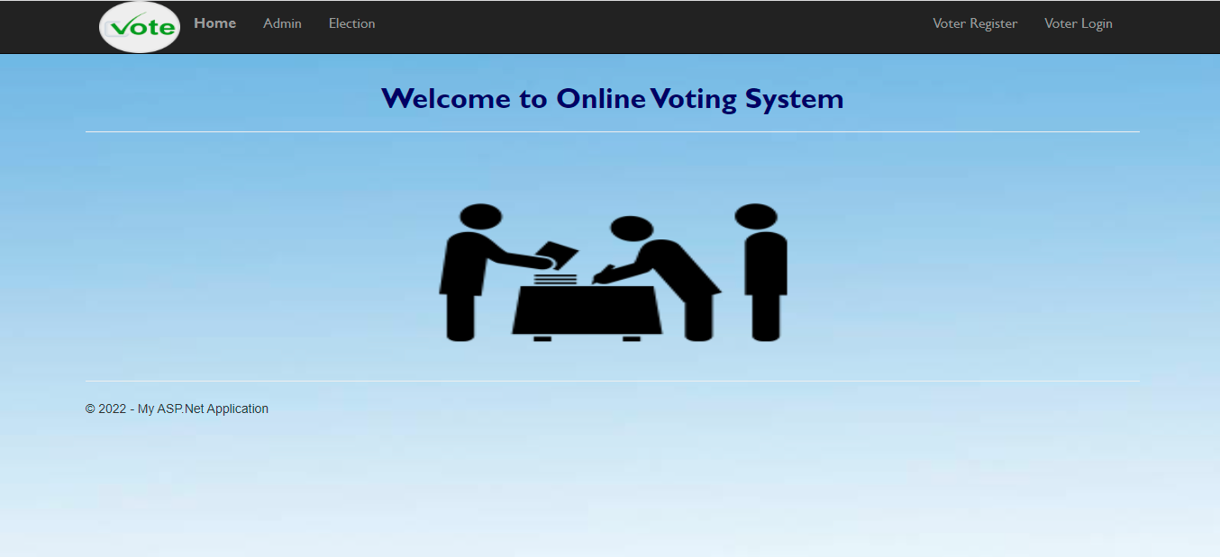

CODING OF WELCOME FORM
using System;
using System.Collections.Generic;
using System.Linq;
using System.Web;
using System.Web.UI;
using System.Web.UI.WebControls;

namespace Online_Voting_System.Design
{
public partial class Home : System.Web.UI.Page
{
protected void Page_Load(object sender, EventArgs e)
{

}
}
}

ADMIN SECTION
ADMIN LOGIN
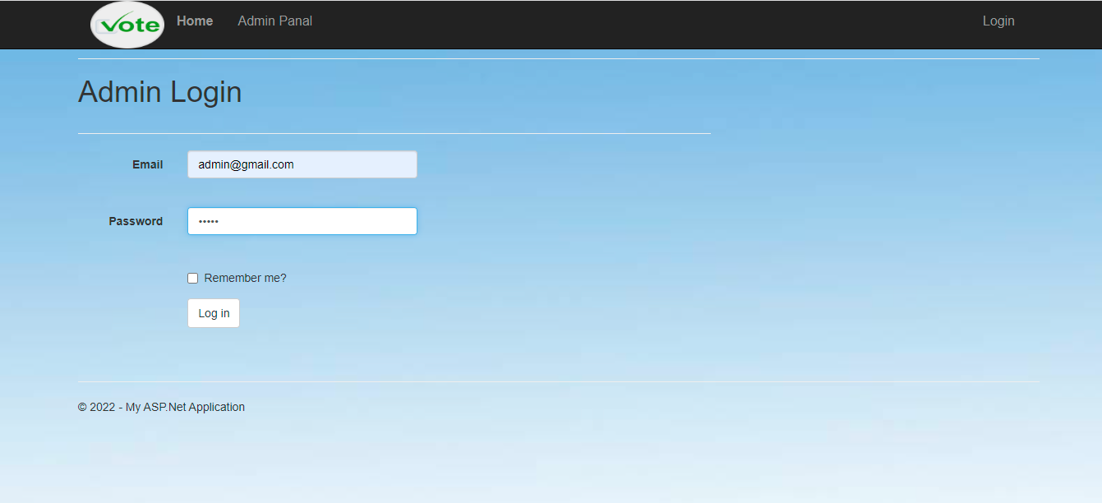
CODING OF ADMIN LOGIN
using System;
using System.Collections.Generic;
using System.Linq;
using System.Web;
using System.Web.UI;
using System.Web.UI.WebControls;

namespace Online_Voting_System.Design.Admin
{
public partial class AdminLogin1 : System.Web.UI.Page
{
protected void Page_Load(object sender, EventArgs e)
{

}

protected void LogIn(object sender, EventArgs e)
{
if (Email.Text == "admin@gmail.com" && Password.Text == "admin")
{
Session["Admin"] = Email.Text;
Session.Timeout = 10;
Response.Redirect("admin.aspx");
ScriptManager.RegisterStartupScript(this, this.GetType(), "popup", "alert('Login Successfully');window.location='AdminLogin.aspx';", true);

}
else
{
ScriptManager.RegisterStartupScript(this, this.GetType(), "popup", "alert('UserId or Password Does Not Match');window.location='AdminLogin.aspx';", true);

}
}
}
}

ADMIN WELCOME



ADMIN’S WELCOME PAGE CODING
using System;
using System.Collections.Generic;
using System.Linq;
using System.Web;
using System.Web.UI;
using System.Web.UI.WebControls;

namespace Online_Voting_System.Design.Admin
{
public partial class admin : System.Web.UI.Page
{
protected void Page_Load(object sender, EventArgs e)
{

}
}
}

ADD CANDIDATE
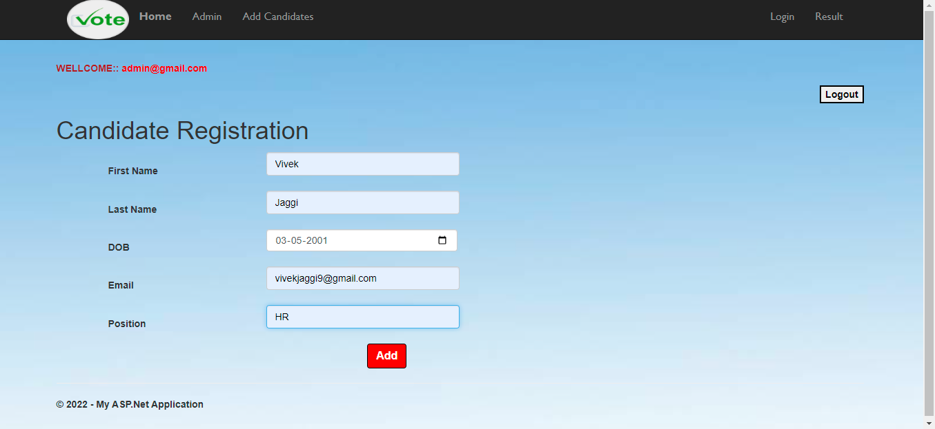

CODING TO ADD CANDIDATE
using System;
using System.Collections.Generic;
using System.Linq;
using System.Web;
using System.Web.UI;
using System.Web.UI.WebControls;
using System.Configuration;
using System.Data.SqlClient;
using System.Data;

namespace Online_Voting_System.Design.Admin
{
public partial class AddCandidates : System.Web.UI.Page
{
protected void Page_Load(object sender, EventArgs e)
{
Label2.Text = "<b><font color=Brown>" + "WELLCOME:: " + "</font>" + "<b><font color=red>" + Session["Admin"] + "</font>";

if (Session["Admin"] == null)
{
Session.Abandon();
Response.Redirect("~/Design/Admin/AdminLogin.aspx");
}
}

protected void btnAddCandidate_Click(object sender, EventArgs e)
{
try
{
SqlConnection con = new SqlConnection(ConfigurationManager.ConnectionStrings["dbvoting"].ConnectionString);
con.Open();

string insert = "insert into Candidates values(@Name,@DOB,@Email,@Position)";
SqlCommand cmd = new SqlCommand(insert, con);

string message = "Voter Registered successfully.";
string script = "window.onload = function(){ alert('";

cmd.Parameters.AddWithValue("@Name", CFname.Text +" "+ CLname.Text);
cmd.Parameters.AddWithValue("@DOB ", Cdob.Text);
cmd.Parameters.AddWithValue("@Email ", Email.Text);
cmd.Parameters.AddWithValue("@Position", Cposition.Text);

cmd.ExecuteNonQuery();

ScriptManager.RegisterStartupScript(this, this.GetType(), "popup", "alert('Candidate Registered successfully.');window.location='AddCandidates.aspx';", true);

script += message;
script += "')};";
ClientScript.RegisterStartupScript(this.GetType(), "SuccessMessage", script, true);

// }

con.Close();
}
catch (Exception ex)
{
// ScriptManager.RegisterStartupScript(this, this.GetType(), "popup", "alert('Candidate not Registered.Try Again.');window.location='AddCandidates.aspx';", true);

Response.Write(ex.Message);
}

}

protected void btnLogout_Click(object sender, EventArgs e)
{
Session["Admin"] = null;

ScriptManager.RegisterStartupScript(this, this.GetType(), "popup", "alert('Logout Successfully');window.location='AddCandidates.aspx';", true);
Session.Abandon();
Response.Redirect("~/Design/Admin/AdminLogin.aspx");
}
}
}
VOTING RESULT
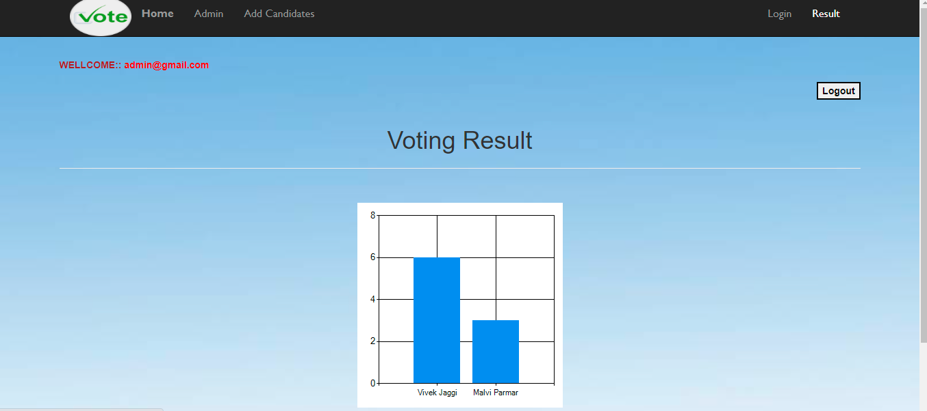

VOTING RESULT CODING
using System;
using System.Collections.Generic;
using System.Linq;
using System.Web;
using System.Web.UI;
using System.Web.UI.WebControls;
using System.Configuration;
using System.Data.SqlClient;
using System.Data;

namespace Online_Voting_System.Design.Admin
{
public partial class Result : System.Web.UI.Page
{
SqlConnection con = new SqlConnection(ConfigurationManager.ConnectionStrings["dbvoting"].ConnectionString);

protected void Page_Load(object sender, EventArgs e)
{
Label1.Text = "<b><font color=Brown>" + "WELLCOME:: " + "</font>" + "<b><font color=red>" + Session["Admin"] + "</font>";

if (Session["Admin"] == null)
{
Session.Abandon();
Response.Redirect("~/Design/Admin/AdminLogin.aspx");
}
}

protected void btnLogout_Click(object sender, EventArgs e)
{
ScriptManager.RegisterStartupScript(this, this.GetType(), "popup", "alert('Logout Successfully');window.location='Result.aspx';", true);
Session.Abandon();
Response.Redirect("~/Design/Admin/admin.aspx");
}

protected void btndelete_Click(object sender, EventArgs e)
{
con.Open();

string deleteQuery = "DELETE FROM Candidates; DELETE FROM UserVoted; DELETE FROM vote;";
SqlCommand cmd = new SqlCommand(deleteQuery, con);
{

cmd.ExecuteNonQuery();
ScriptManager.RegisterStartupScript(this, this.GetType(), "popup", "alert('Delete successfully');window.location='AddCandidates.aspx';", true);

}
con.Close();
}

protected void LinkButton1_Click(object sender, EventArgs e)
{
con.Open();

string deleteQuery = "DELETE FROM vote; DELETE FROM UserVoted; DELETE FROM Candidates;";
SqlCommand cmd = new SqlCommand(deleteQuery, con);
{

cmd.ExecuteNonQuery();
ScriptManager.RegisterStartupScript(this, this.GetType(), "popup", "alert('Delete successfully');window.location='AddCandidates.aspx';", true);

}
con.Close();
}
}
}

USER SECTION

HOME PAGE
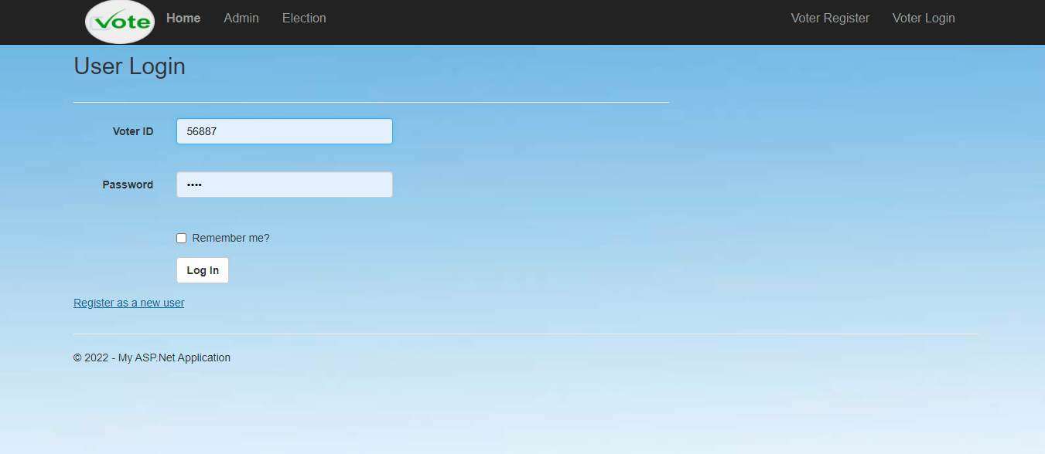

CODING OF USER’S HOME PAGE
using System;
using System.Collections.Generic;
using System.Linq;
using System.Web;
using System.Web.UI;
using System.Web.UI.WebControls;

namespace Online_Voting_System.Design
{
public partial class Home : System.Web.UI.Page
{
protected void Page_Load(object sender, EventArgs e)
{

}
}
}

REGISTER AS A NEW USER
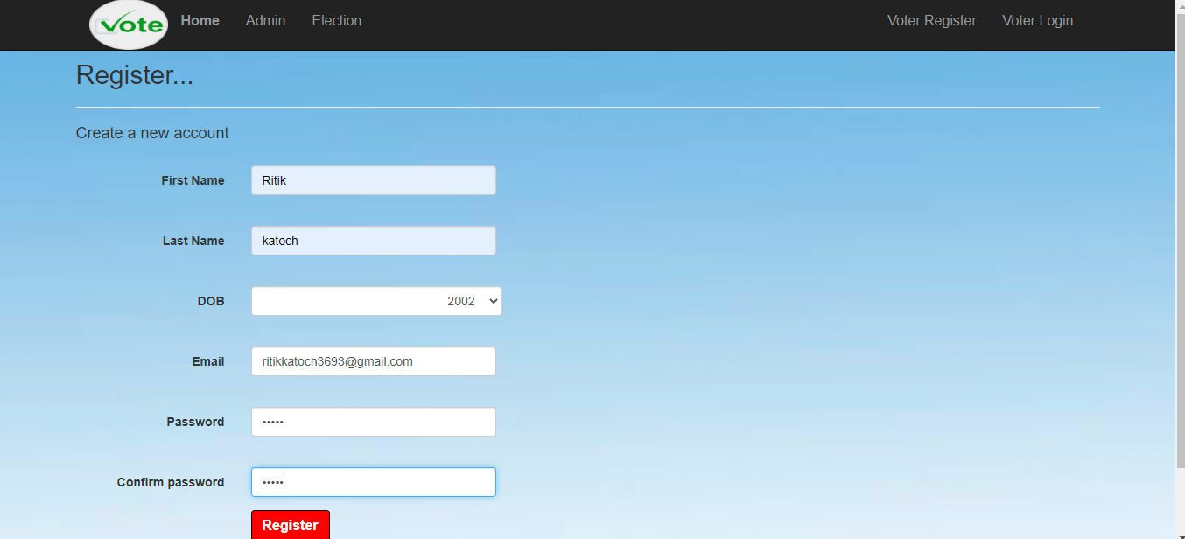
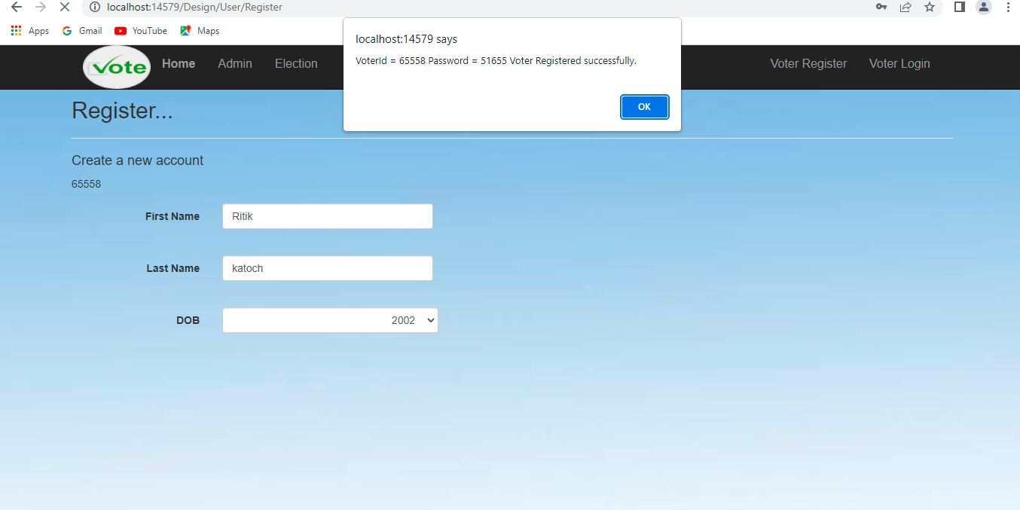
CODING OF NEW USER REGISTRATION
using System;
using System.Linq;
using System.Web;
using System.Web.UI;
using Microsoft.AspNet.Identity;
using Microsoft.AspNet.Identity.Owin;
using Owin;
using Online_Voting_System.Models;
using System.Configuration;
using System.Data.SqlClient;
using System.Data;

namespace Online_Voting_System.Account
{
public partial class Register : Page
{
SqlConnection con = new SqlConnection(ConfigurationManager.ConnectionStrings["dbvoting"].ConnectionString);
protected void Page_Load(object sender, EventArgs e)
{
Random r = new Random();
int i = r.Next(12345, 98765);
Id_hfd.Value = i.ToString();

if (!IsPostBack)
{
for (int n = 1947; n <= 2020; n++)
{
txtdob.Items.Add(n.ToString());
}
}

}
protected void CreateUser_Click(object sender, EventArgs e)
{
SqlDataAdapter da = new SqlDataAdapter("select year(getdate())", con);
DataTable dt = new DataTable();
da.Fill(dt);
int i = Convert.ToInt32(dt.Rows[0][0].ToString());
int j = Convert.ToInt32(txtdob.SelectedValue);
int k = i - j;
if (k >= 18)
{
Label1.Text = k.ToString();

try
{
SqlConnection con = new SqlConnection(ConfigurationManager.ConnectionStrings["dbvoting"].ConnectionString);
con.Open();
string insert = "insert into registeruser values(@VoterId,@Name,@DOB,@Age,@Email,@password)";
SqlCommand cmd = new SqlCommand(insert, con);

string message = "Voter Registered successfully.";
string script = "window.onload = function(){ alert('";
Label2.Text = Id_hfd.Value;

cmd.Parameters.AddWithValue("VoterId", Label2.Text);
cmd.Parameters.AddWithValue("Name ", Fname.Text+" "+ Lname.Text);
cmd.Parameters.AddWithValue("DOB", txtdob.Text);
cmd.Parameters.AddWithValue("Age", Label1.Text);

cmd.Parameters.AddWithValue("Email", Email.Text);
cmd.Parameters.AddWithValue("password", Password.Text);

script += "VoterId = " + Label2.Text + " ";
script += "Password = " + Password.Text + " ";
cmd.ExecuteNonQuery();

// ScriptManager.RegisterStartupScript(this, this.GetType(), "popup", "alert('Voter Registered successfully.');window.location='VoterRegister.aspx';", true);

script += message;
script += "')};";
ClientScript.RegisterStartupScript(this.GetType(), "SuccessMessage", script, true);

con.Close();
}
catch (Exception ex)
{
ScriptManager.RegisterStartupScript(this, this.GetType(), "popup", "alert('Voter not Registered.Try Again.');window.location='VoterRegister.aspx';", true);

Response.Write(ex.Message);
}
}
else
{
ErrorMessage.Text = "You are not Eligible for applying voter id";
}

}

}
}

VOTING SYSTEM

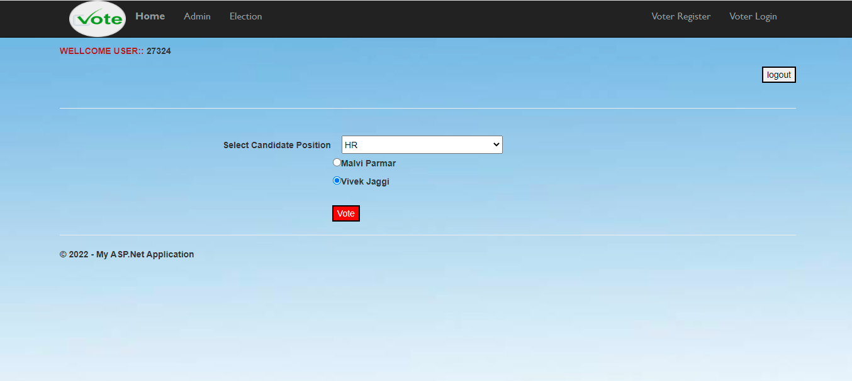

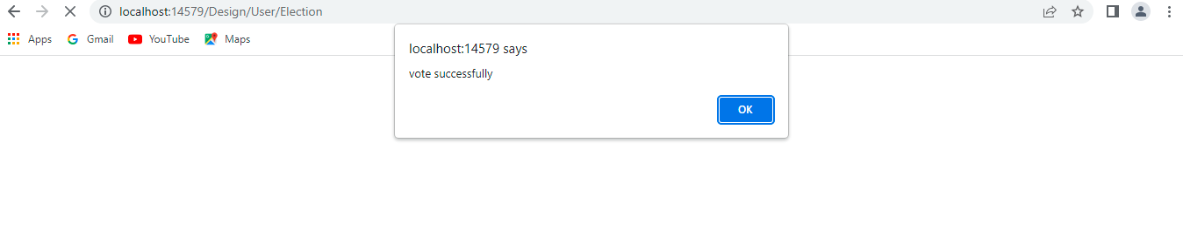

CODING OF VOTING SYSTEM
using System;
using System.Collections.Generic;
using System.Linq;
using System.Web;
using System.Web.UI;
using System.Web.UI.WebControls;
using System.Configuration;
using System.Data.SqlClient;
using System.Data;

namespace Online_Voting_System.Design.User
{
public partial class Election : System.Web.UI.Page
{
protected void Page_Load(object sender, EventArgs e)
{
string username = Session["VoterId"] as string;
Label2.Text = username;
Label4.Text = "<b><font color=Brown>" + "WELLCOME USER:: " + "</font>";

if (Session["VoterId"] == null)
{
Session.Abandon();
Response.Redirect("~/Design/User/Login.aspx");
}

}

protected void btnsubmit_Click(object sender, EventArgs e)
{
try
{
SqlConnection con = new SqlConnection(ConfigurationManager.ConnectionStrings["dbvoting"].ConnectionString);

con.Open();

SqlDataSource sds1 = new SqlDataSource();
sds1.ConnectionString = ConfigurationManager.ConnectionStrings["dbvoting"].ToString();
sds1.SelectParameters.Add("VoterId", TypeCode.String, this.Label2.Text);
sds1.SelectCommand = "SELECT * FROM [UserVoted] WHERE [VoterId]=@VoterId";

DataView dv1 = (DataView)sds1.Select(DataSourceSelectArguments.Empty);
if (dv1.Count == 0)
{

string insert = "insert into UserVoted values('" + this.Label2.Text + "')";
SqlCommand cmd = new SqlCommand(insert,con);
cmd.ExecuteNonQuery();

SqlDataSource sds = new SqlDataSource();
sds.ConnectionString = ConfigurationManager.ConnectionStrings["dbvoting"].ToString();
sds.SelectParameters.Add("Name", TypeCode.String, this.RadioButtonList1.SelectedValue);
sds.SelectCommand = "SELECT * FROM [vote] WHERE [Name]=@Name";

DataView dv = (DataView)sds.Select(DataSourceSelectArguments.Empty);
if (dv.Count == 0)
{
int vote = 0;
string command = "insert into vote values(@Name,'" + vote + "')";
SqlCommand cmd1 = new SqlCommand(command, con);
cmd1.Parameters.AddWithValue("@Name", RadioButtonList1.SelectedValue);

cmd1.ExecuteNonQuery();
string command3 = "update vote set vote=vote+1 where Name=@Name";
SqlCommand cmd3 = new SqlCommand(command3, con);
cmd3.Parameters.AddWithValue("@Name", RadioButtonList1.SelectedValue);
cmd3.ExecuteNonQuery();

ScriptManager.RegisterStartupScript(this, this.GetType(), "popup", "alert('vote successfully');window.location='Election.aspx';", true);
return;
}
else
{
string command1 = "update Vote set vote=vote+1 where Name=@Name";
SqlCommand cmd1 = new SqlCommand(command1, con);
cmd1.Parameters.AddWithValue("@Name", RadioButtonList1.SelectedValue);
cmd1.ExecuteNonQuery();
ScriptManager.RegisterStartupScript(this, this.GetType(), "popup", "alert('vote successfully');window.location='Election.aspx';", true);

}
}
else
{
ScriptManager.RegisterStartupScript(this, this.GetType(), "popup", "alert('Already voted!');window.location='Election.aspx';", true);

}

}

catch (Exception ex)
{

Label3.Text = ex.Message;
//"Please enter you Voter ID or select candidates !";
}

}

protected void btnLogout_Click(object sender, EventArgs e)
{
Session["VoterID"] = null;

ScriptManager.RegisterStartupScript(this, this.GetType(), "popup", "alert('Logout Successfully');window.location='Election.aspx';", true);
Session.Abandon();
Response.Redirect("~/Design/Home.aspx");
}

protected void DropDownList1_SelectedIndexChanged(object sender, EventArgs e)
{

}
}
}

DATABASES

DATABASE OF NEW USER REGISTRATION

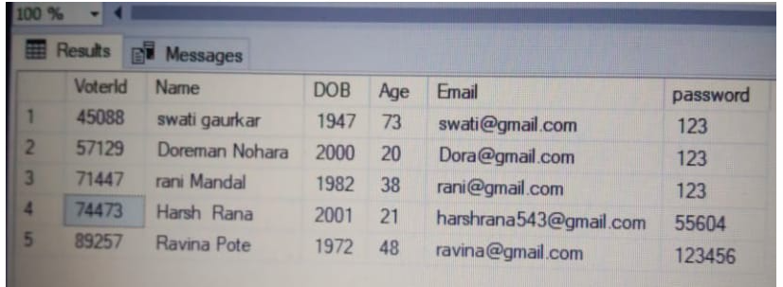

DATABASE OF CANDIDATES

